**Button control**

The Button control represents a standard Windows button. It is generally used to generate a Click event by providing a handler for the Click event.

Let's create a label by dragging a Button control from the Toolbox ad dropping it on the form.

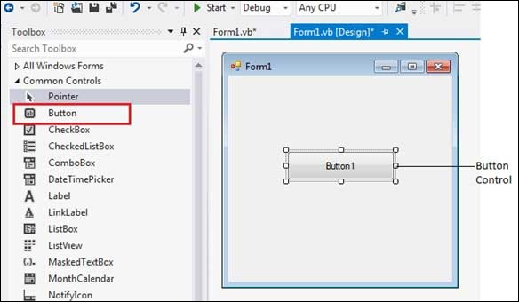

**Properties of the Button Control**

The following are some of the commonly used properties of the Button control –

1. AutoSizeMode



Gets or sets the mode by which the Button automatically resizes itself.

2.BackColor

Gets or sets the background color of the control.

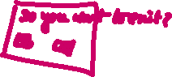

3.BackgroundImage

Gets or sets the background image displayed in the control.

4.ForeColor

Gets or sets the foreground color of the control.

5.Image

Gets or sets the image that is displayed on a button control.

6.Text

Gets or sets the text associated with this control.

**Events of the Button Control**

The following are some of the commonly used events of the Button control −

1.Click

Occurs when the control is clicked.

2.DoubleClick

Occurs when the user double-clicks the Button control.

3.GetFocus

Occurs when the control receives focus.

**Example**

In the following example, we create three buttons. In this example, let us −

Set captions for the buttons

Set some image for the button

Handle the click events of each buttons

Take following steps −

Drag and drop a Label control on the form.

Set the Text property to provide the caption "Vb.Net Button ".

Drag and drop three buttons on the form.

Using the properties window, change the Name properties of the buttons to btnMoto, btnLogo and btnExit respectively.

Using the properties window, change the Text properties of the buttons to Show Moto, Show Logo and Exit respectively.

Drag and Drop another button, using the properties window, set its Image property and name it btnImage.

At this stage, the form looks like-

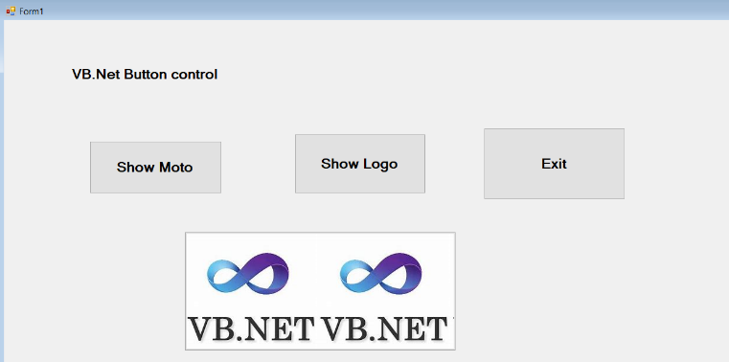

Click the form and add following code in the code editor −

Public Class Form1

Private Sub btnMoto_Click(sender As Object, e As EventArgs) Handles btnMoto.Click

btnImage.Visible = False

Label1.Text = "Enjoy the programming of VB.Net"

End Sub

Private Sub btnExit_Click(sender As Object, e As EventArgs) Handles btnExit.Click

End

End Sub

Private Sub btnLogo_Click(sender As Object, e As EventArgs) Handles btnLogo.Click

Label1.Visible = False

btnImage.Visible = True

End Sub

Private Sub Form1_Load(sender As Object, e As EventArgs) Handles MyBase.Load

' Set the caption bar text of the form.

Me.Text = "Vb.Net Button”

btnImage.Visible = False

End Sub

End Class

**Label Control**

The Label control represents a standard Windows label. It is generally used to display some informative text on the GUI which is not changed during runtime.

Let's create a label by dragging a Label control from the Toolbox and dropping it on the form.

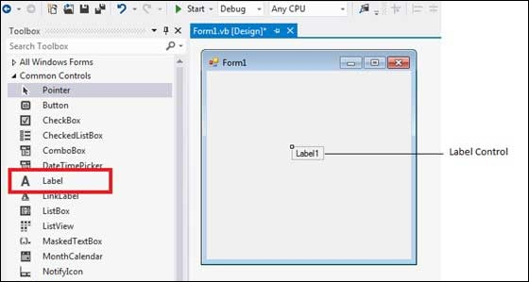

Properties of the Label Control

The following are some of the commonly used properties of the Label control –

|  |  |
| --- | --- |
| 1 | **Autosize**  Gets or sets a value specifying if the control should be automatically resized to display all its contents. |
| 2 | **BorderStyle**  Gets or sets the border style for the control. |
| 3 | **FlatStyle**  Gets or sets the flat style appearance of the Label control |
| 4 | **Font**  Gets or sets the font of the text displayed by the control. |
| 5 | **FontHeight**  Gets or sets the height of the font of the control. |
| 6 | **ForeColor**  Gets or sets the foreground color of the control. |
| 7 | **PreferredHeight**  Gets the preferred height of the control. |
| 8 | **PreferredWidth**  Gets the preferred width of the control. |
| 9 | **Text**  Gets or sets the text associated with this control. |
| 10 | **TextAlign**  Gets or sets the alignment of text in the label. |

Events of the Label Control

The following are some of the commonly used events of the Label control −

|  |  |
| --- | --- |
| **Sr.No.** | **Event & Description** |
| 1 | **AutoSizeChanged**  Occurs when the value of the AutoSize property changes. |
| 2 | **Click**  Occurs when the control is clicked. |
| 4 | **GetFocus**  Occurs when the control receives focus. |

**Example**

Following is an example, which shows how we can create two labels. Let us create the first label from the designer view tab and set its properties from the properties window. We will use the Click and the DoubleClick events of the label to move the first label and change its text and create the second label and add it to the form, respectively.

Take the following steps −

Drag and drop a Label control on the form.

Set the Text property to provide the caption "This is a Label Control".

Set the Font property from the properties window.

Click the label to add the Click event in the code window and add the following codes.

Public Class Form1

Private Sub Form1_Load(sender As Object, e As EventArgs) Handles MyBase.Load

' Set the caption bar text of the form.

Me.Text = "Vb.Net Label Control"

End Sub

Private Sub Label1_Click(sender As Object, e As EventArgs) Handles Label1.Click

Label1.Location = New Point(50, 50)

Label1.Text = "You have just moved the label"

End Sub

End Class

When the above code is executed and run using Start button available at the Microsoft Visual Studio tool bar, it will show the following window

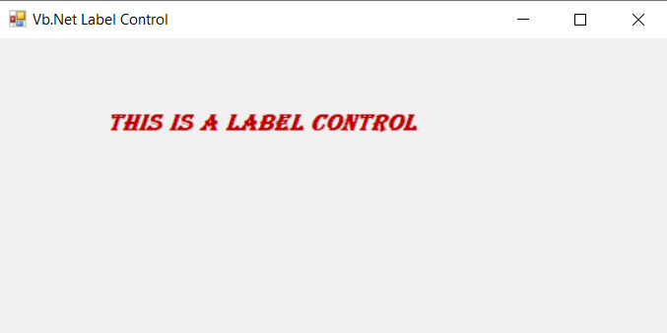

Clicking the label would produce the following effect

